Balisacan, Mark Justin F. BSIT 4-1 WMAD
Binuya, John Lloyd A.
Reyes, Allysa B.

WEEK 2: Development Environment Setup and Initial Coding

I. INTENDED LEARNING OUTCOME
At the end of this activity, students should be able to:
Develop a functional development environment by configuring required software tools, establishing database structures, implementing foundational system modules, and applying coding standards for collaborative software development.

II. PERFORMANCE TASK
Your capstone project has completed the planning phase. As a development team, you must prepare the software development environment, establish database structures, create the repository framework, implement foundational modules, and adopt coding standards to ensure efficient collaboration and future system expansion.

III. WEEK 2 ACTIVITIES
Activity 1 – Development Environment Configuration
Activity 2 – Database Setup and Implementation
Activity 3 – Framework and Project Structure Setup
Activity 4 – Foundational Module Development
Activity 5 – Coding Standards Establishment
Activity 6 – Repository Initialization and Version Control
Activity 7 – Adviser Validation

ACTIVITY 1
DEVELOPMENT ENVIRONMENT CONFIGURATION

Purpose
To ensure that all required development tools and software components are properly installed and configured.
Procedure
- Install all development tools identified in the Development Plan.
- Verify software versions.
- Configure project workspace.
- Test development environment functionality.
- Complete Form 1.

FORM 1
DEVELOPMENT ENVIRONMENT CHECKLIST

Directions
Check all software successfully installed and configured.

Mobile
Tool/Software | Required | Installed | Version
IDE | □ | □ | 1.130.0
Programming Language Runtime | □ | □ | V24.14.0 and v24.14.0
Database Server | □ | □ | PostgreSQL 17.6
Version Control Tool | □ | □ | 2.53.0
Framework | □ | □ | React: 19.2.6”  Vite: 8.0.12
API Testing Tool | □ | □ | 12.21.2

Web
Tool/Software | Required | Installed | Version
IDE | □ | □ | 1.130.0
Programming Language Runtime | □ | □ | Node v22.16.0  npm 10.9.2
Database Server | □ | □ | PostgreSQL (Supabase Cloud) 17.6
Version Control Tool | □ | □ | 2.50.1.windows.1
Framework | □ | □ | Vue.js 3.5.32  Vite 6.4.3
API Testing Tool | □ | □ | Supabase Dashboard / Client (@supabase/supabase-js ^2.106.1)

Environment Test Results
Component Tested | Result
IDE Launch | Pass
Database Connection | Pass
Repository Access | Pass
Framework Execution | Pass

Required Evidence
Mobile
□ Screenshot of Installed Tools
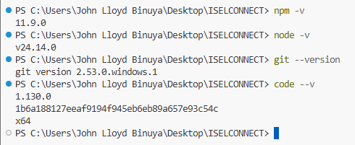
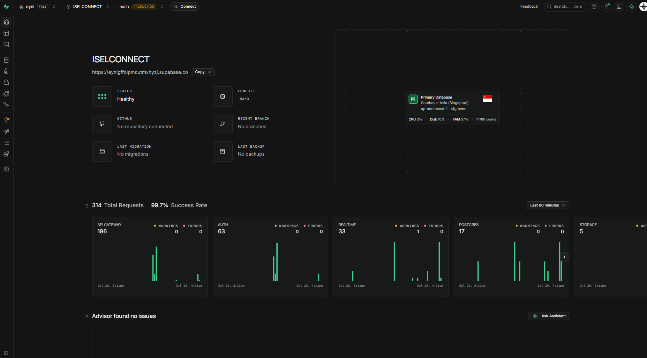 | 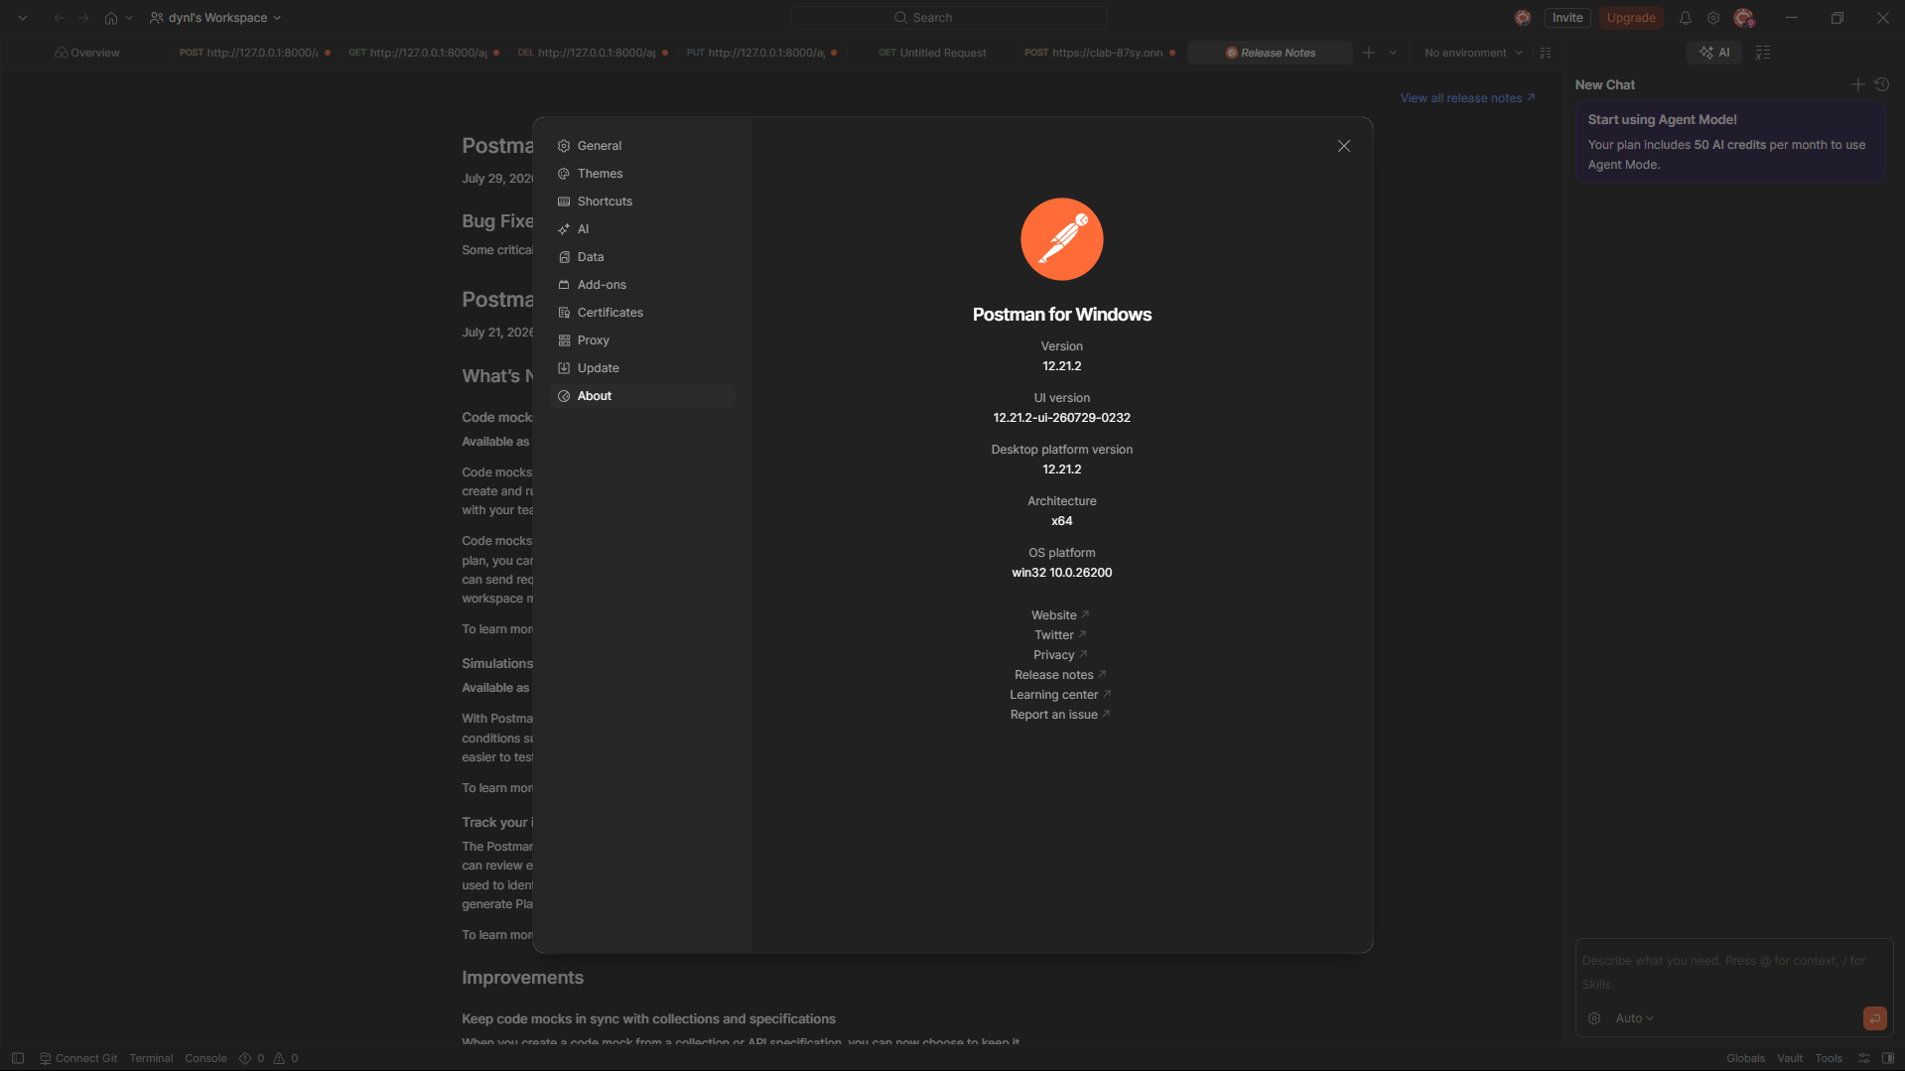
□ Screenshot of Running Development Environment
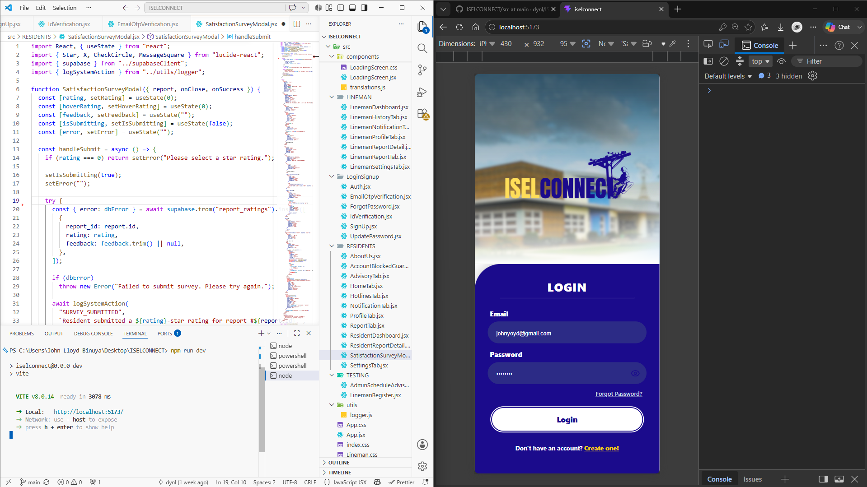

□ Screenshot of Project Workspace
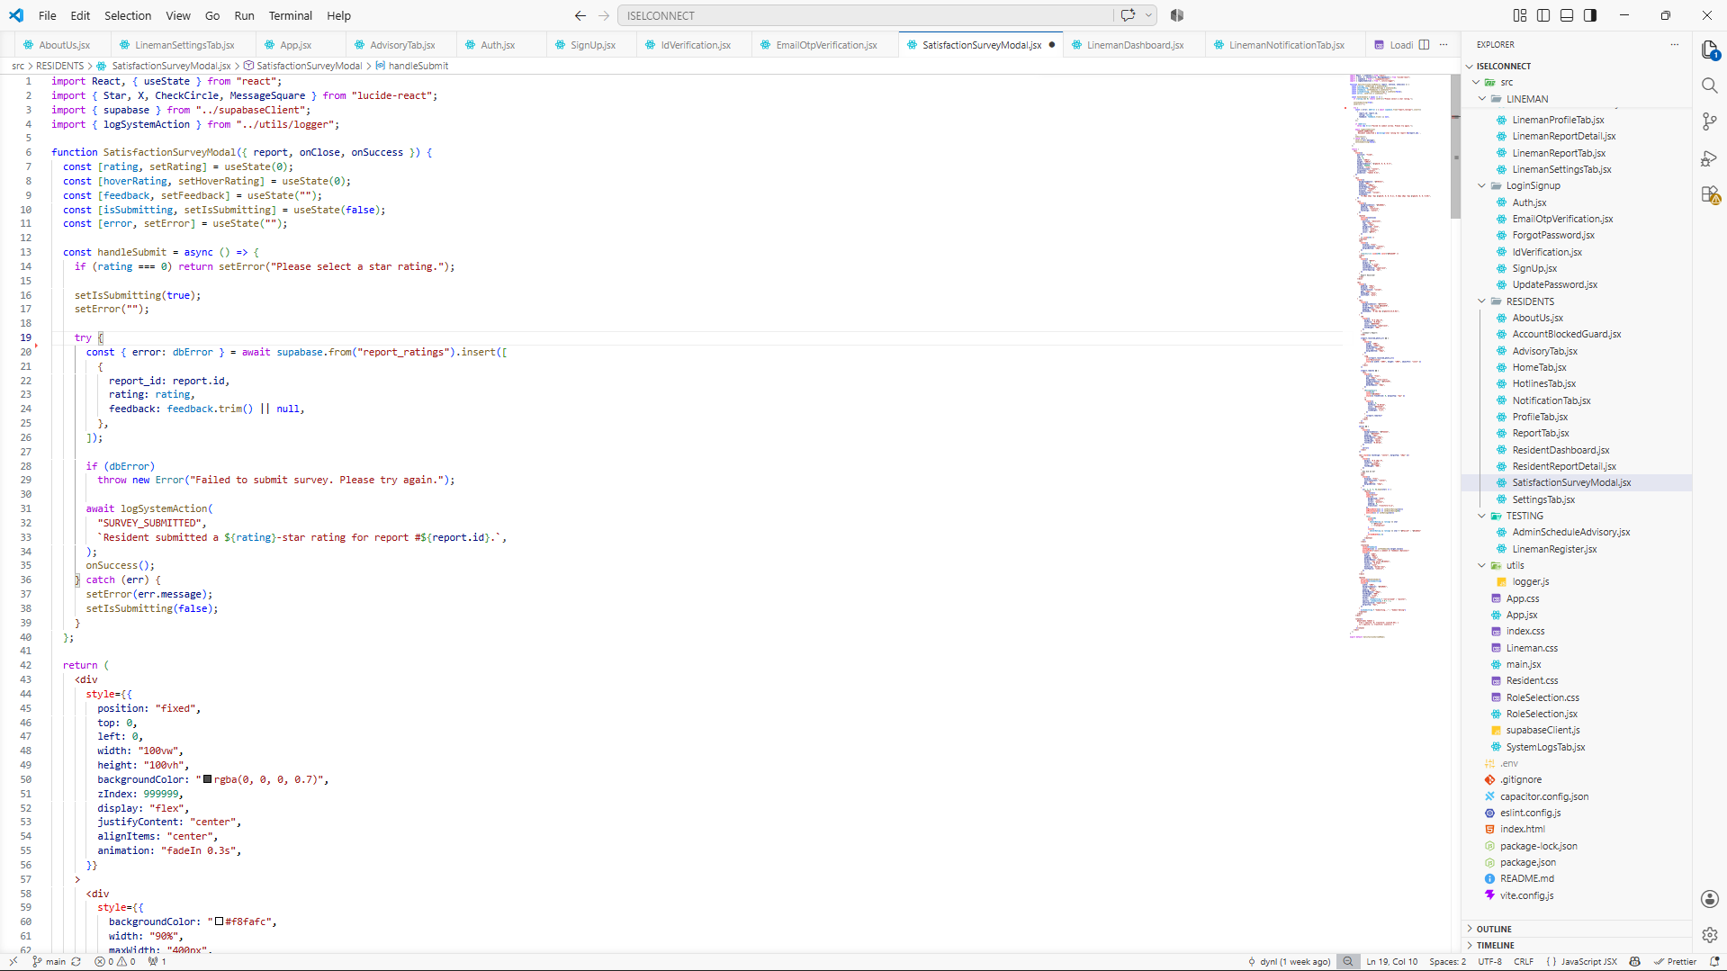

Web
Required Evidence
□ Screenshot of Installed Tools
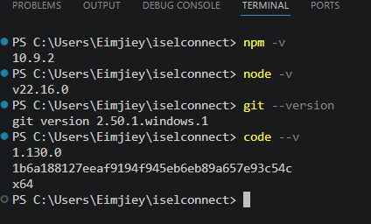
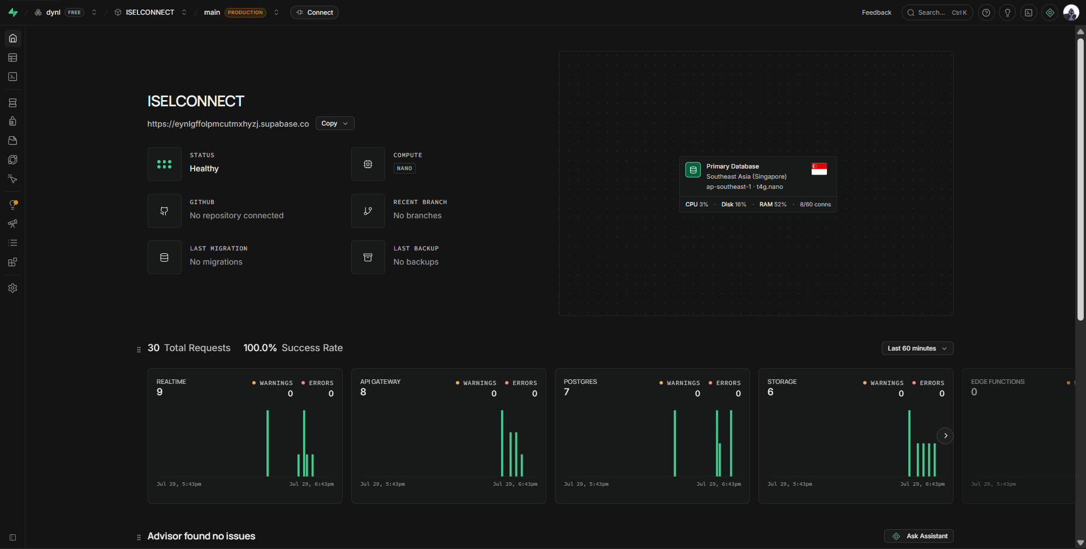
□ Screenshot of Running Development Environment

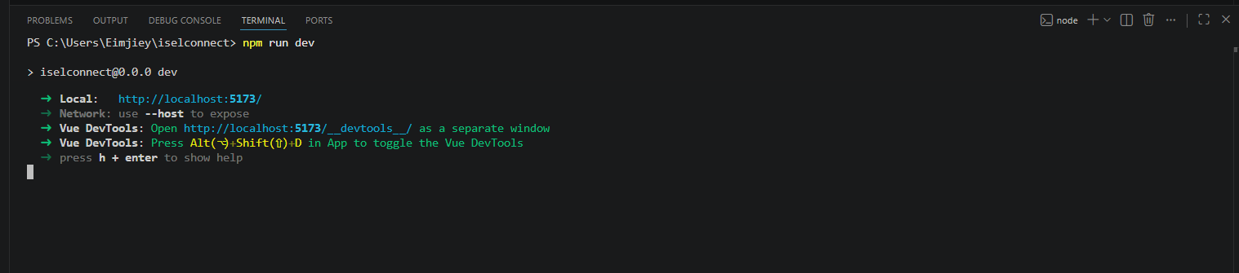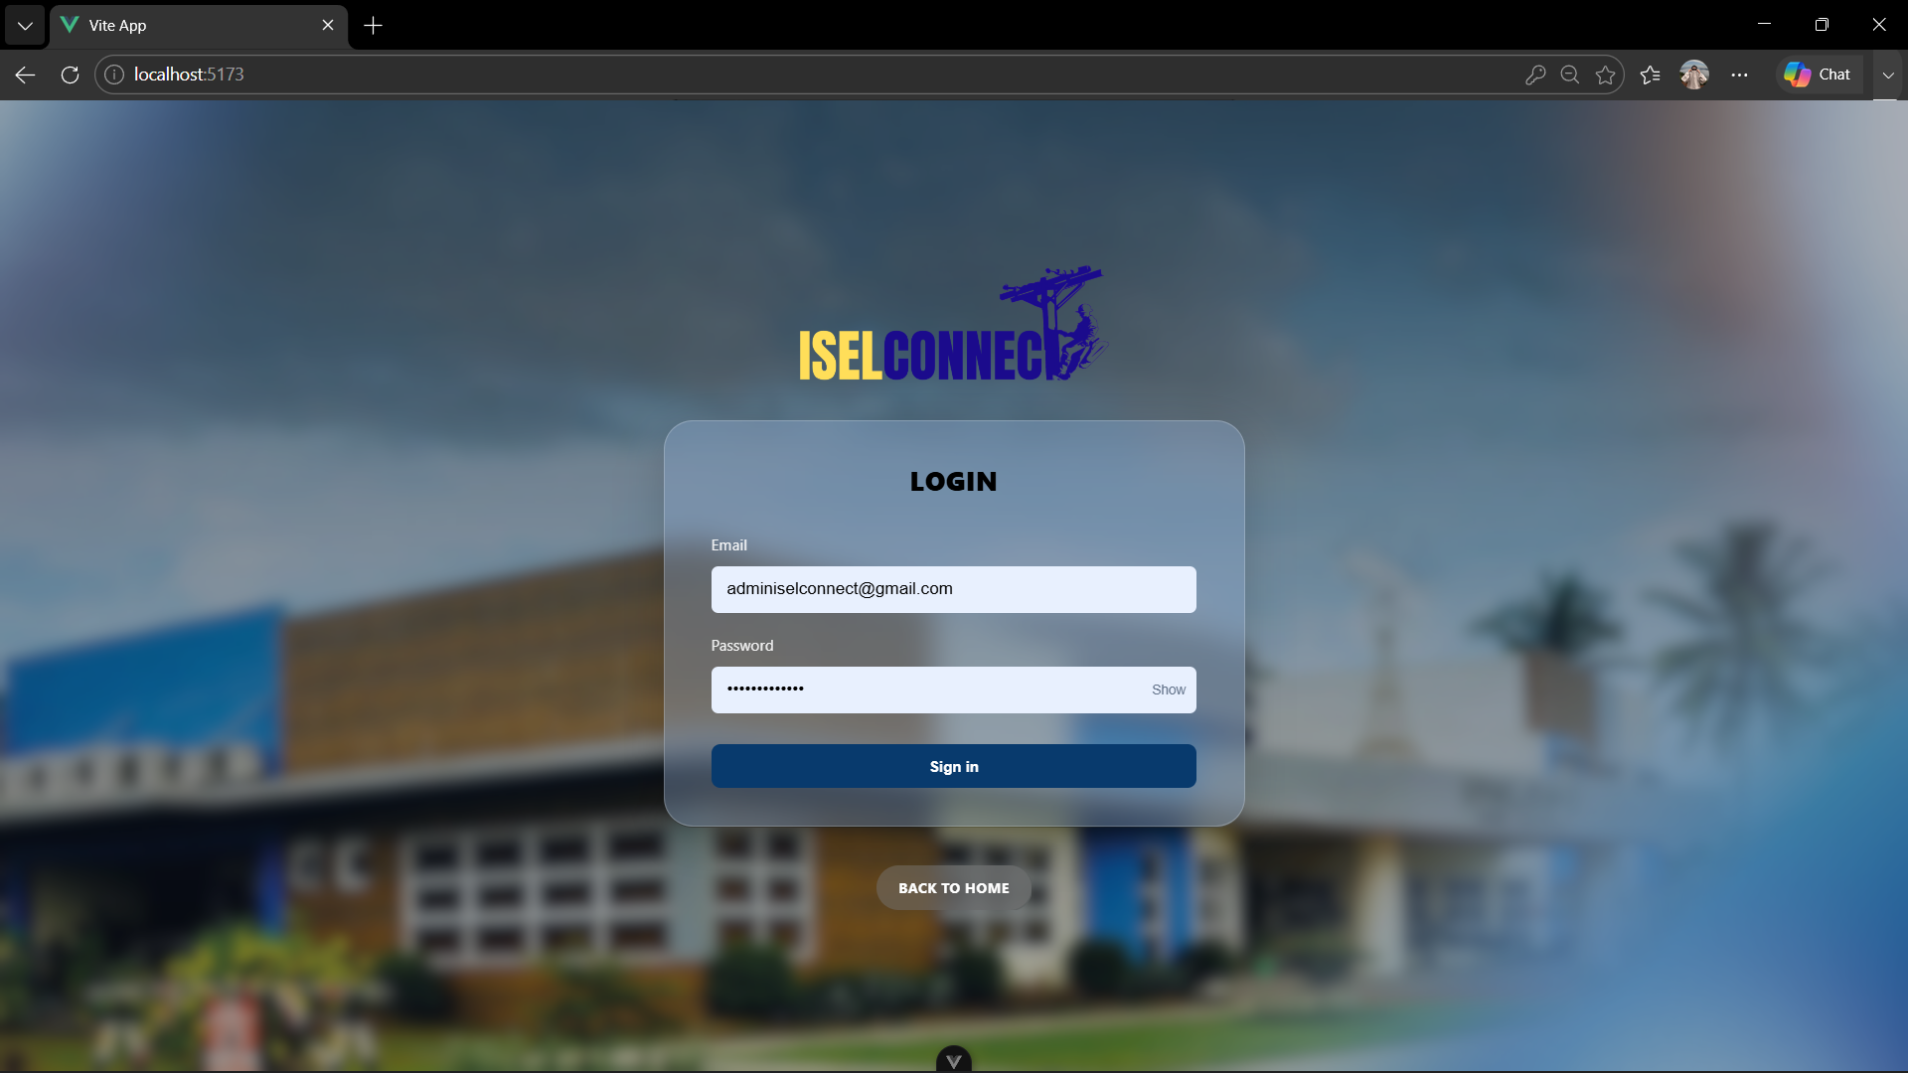

□ Screenshot of Project Workspace
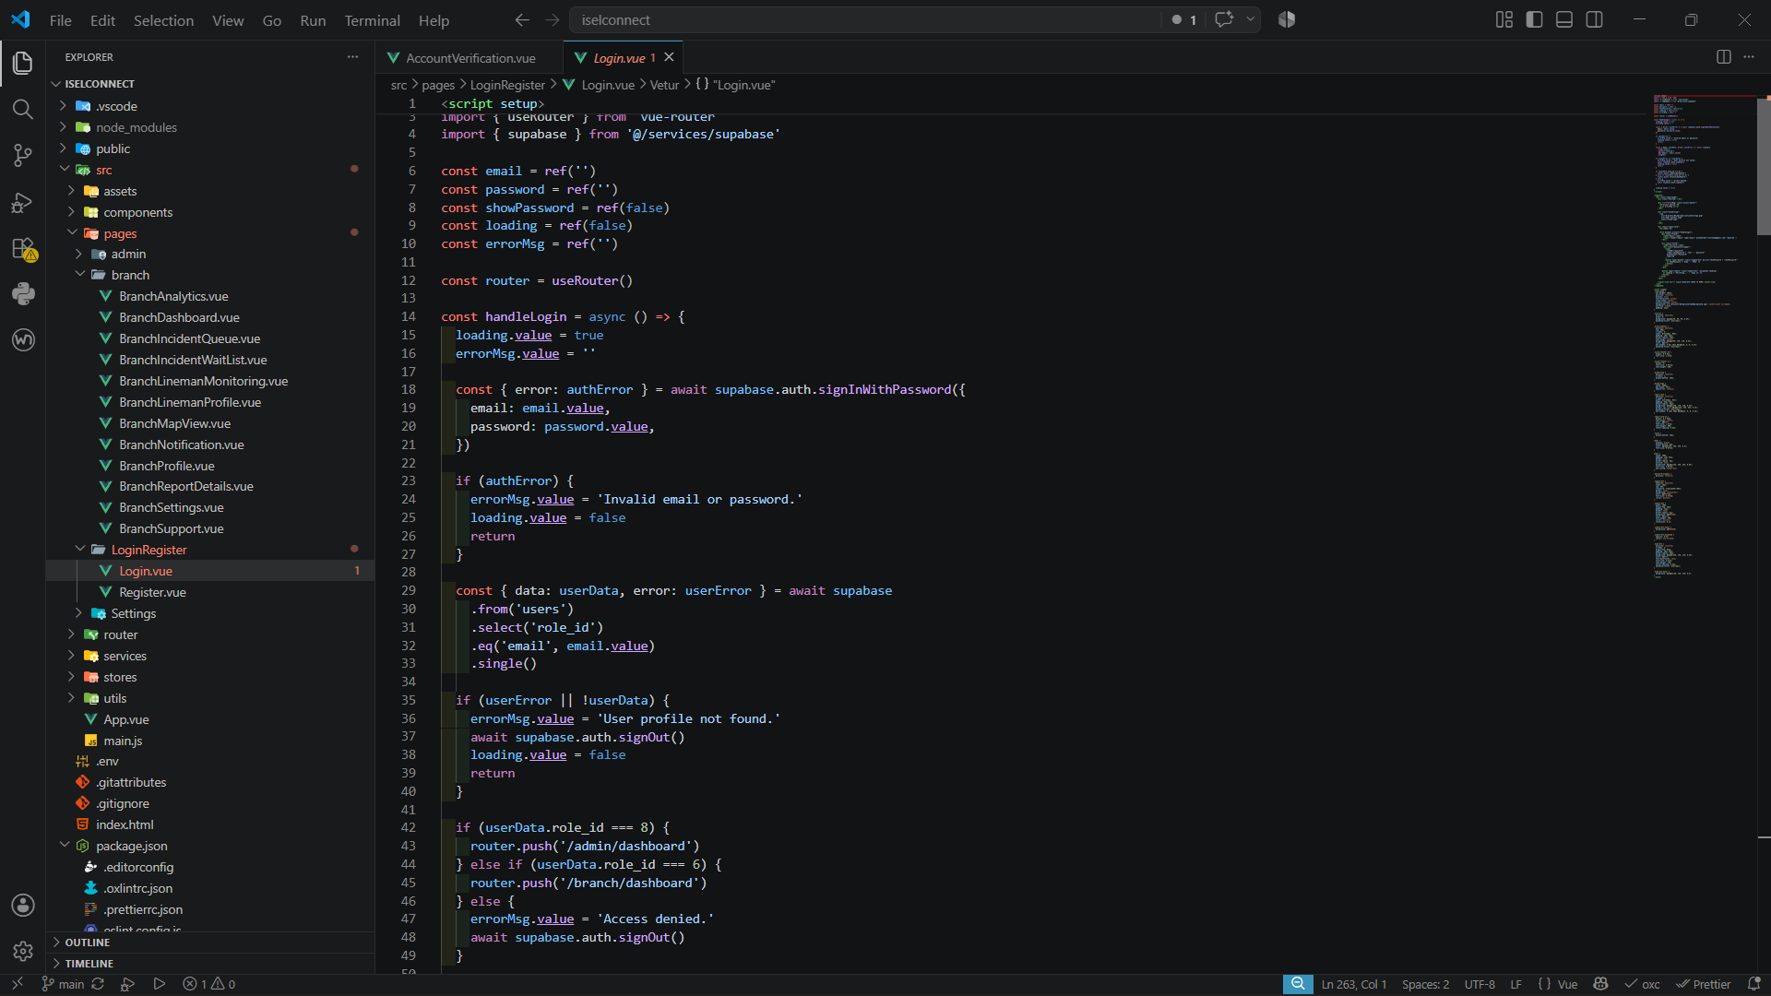

ACTIVITY 2
DATABASE IMPLEMENTATION

Purpose
To create the initial database structure required by the project.
Procedure
- Review the approved ERD.
- Create database schema.
- Create tables and relationships.
- Test database connectivity.
- Complete Form 2.

FORM 2
DATABASE IMPLEMENTATION REPORT

Directions
Document the database created for the project.
Project Database Name: ISELCONNECT

Database Platform: Supabase

Database Tables
Table Name | Purpose
assignments | Stores report assignments given to employees or linemen.
barangays | Stores the list of barangays served by ISELCO-1.
employees | Stores employee information, including linemen and administrative staff.
iselco_branch | Stores information about ISELCO-1 branch offices.
municipalities | Stores municipalities covered by ISELCO-1.
notifications | Stores notifications sent to users regarding outages, maintenance, and report updates.
power_advisories | Stores scheduled power interruption and maintenance advisories.
report_ratings | Stores user ratings and feedback for resolved reports or services.
report_statuses | Stores the possible statuses of reports (e.g., Pending, Verified, Assigned, In Progress, Resolved).
report_types | Stores categories of reports such as power outage, damaged pole, fallen wire, transformer issue, etc.
reports | Stores reports submitted by residents, including location, description, images, and status.
roles | Stores user role definitions such as Administrator, Employee, and Resident.
system_logs | Stores audit logs of important system activities and user actions.
user_verifications | Stores user verification records, including OTP verification and account verification status.
users | Stores registered user accounts, authentication details, and profile information.

Relationships Implemented
Relationship | Status
One-to-One | Implemented
One-to-Many | Implemented
Many-to-Many | Not Applicable

Required Evidence
□ ERD Diagram
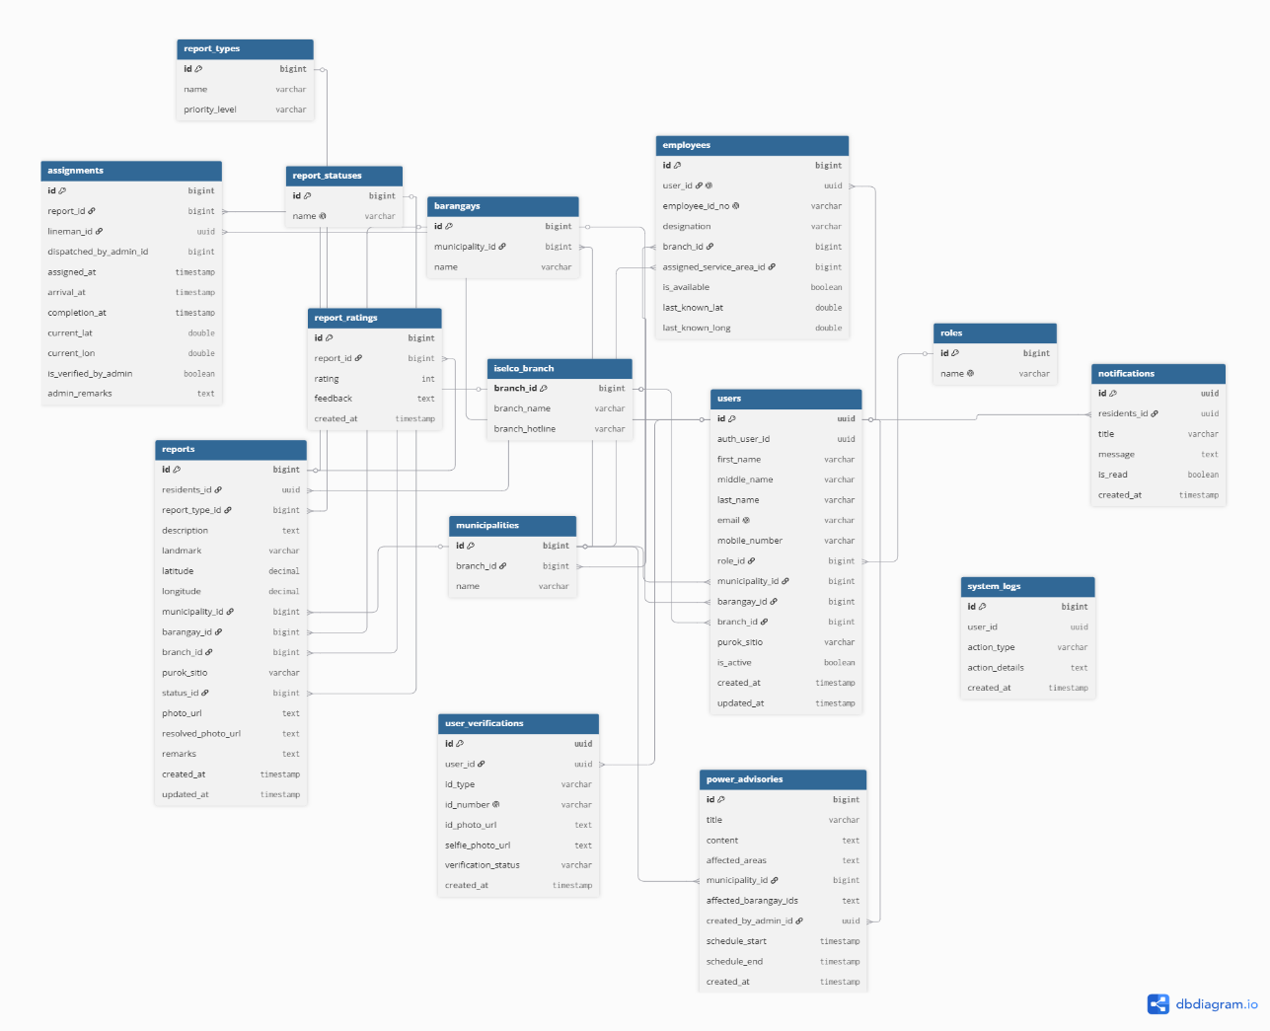

□ Database Screenshot & Table Structure Screenshot
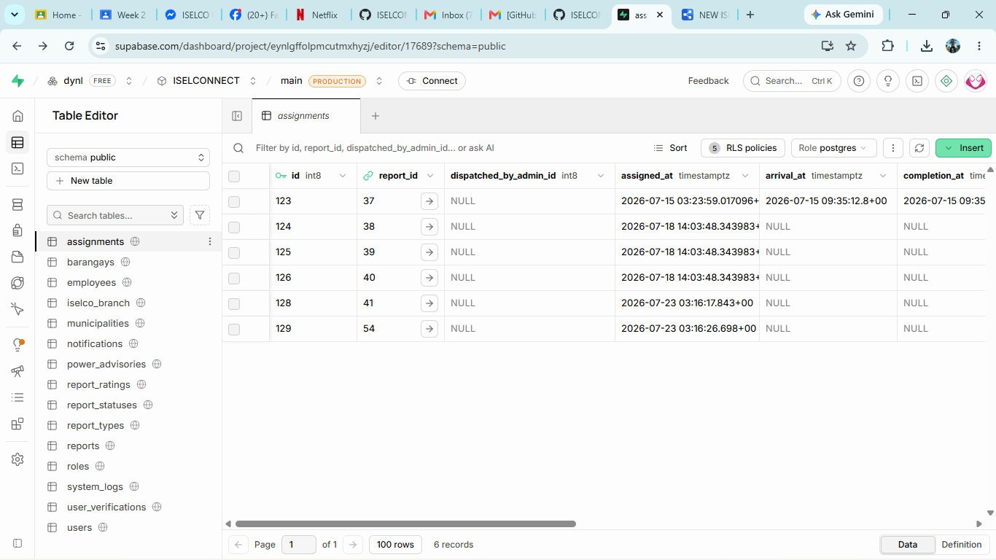

□ Connectivity Test Screenshot
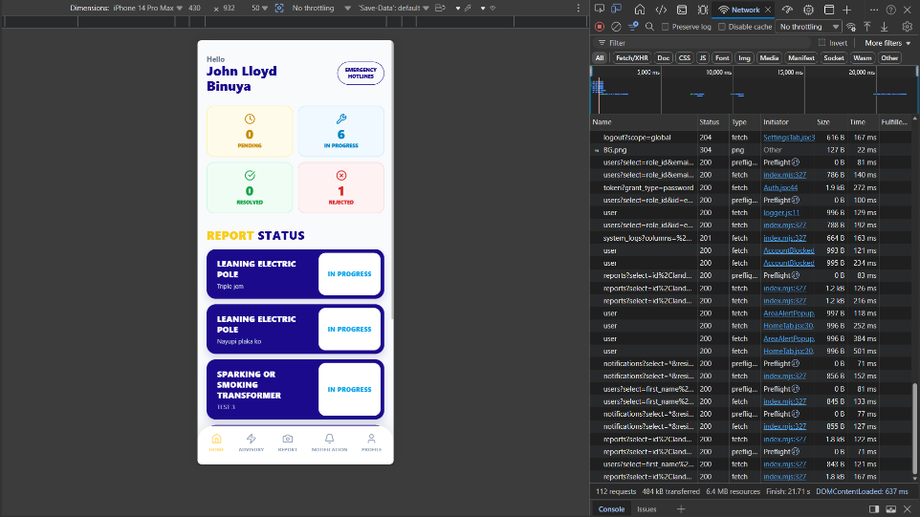

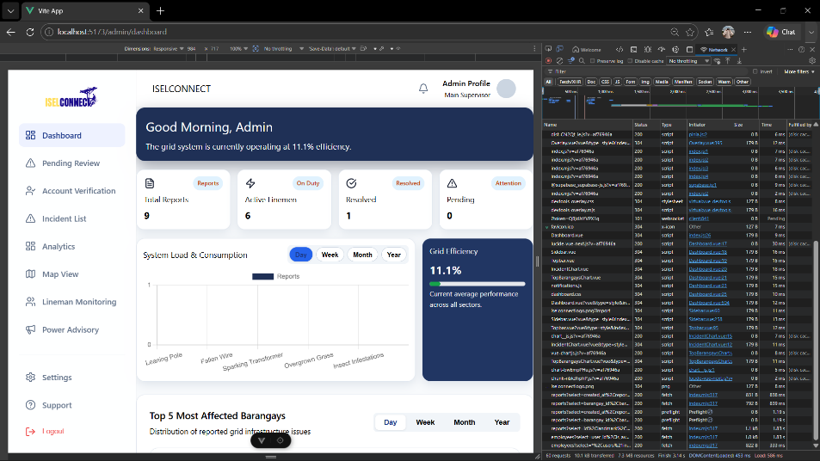

ACTIVITY 3
FRAMEWORK AND PROJECT STRUCTURE SETUP

Purpose
To establish a maintainable project structure for development.
Procedure
- Create application folders.
- Configure framework.
- Create initial configuration files.
- Verify successful project execution.
- Complete Form 3.

FORM 3
PROJECT STRUCTURE REPORT

Directions
Document the project architecture.
Folder | Purpose
frontend | Contains the source code for the Vue.js Web Admin Portal and React Native Mobile Application.
backend | Contains the backend services and API integrations with Supabase.
database | Contains the database schema, SQL scripts, ERD, migrations, and etc.
documentation | Contains project documentation.
testing | Contains test cases, testing reports, bug reports, and test scripts used for system verification and validation.

Framework Configuration

Mobile Framework:
React

Version:
React: 19.2.6”
Vite: 8.0.12

Web Framework:
Vue

Version:
Vue.js 3.5.32
Vite 6.4.3

Project Structure Validation
□ Folder Structure Created
□ Configuration Files Created
□ Framework Running Successfully

Mobile
□ Folder Structure Created  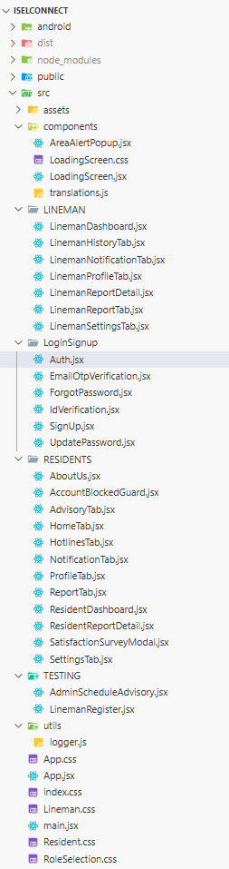 | □ Configuration Files Created  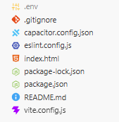
 | □ Framework Running Successfully

Web
□ Folder Structure Created  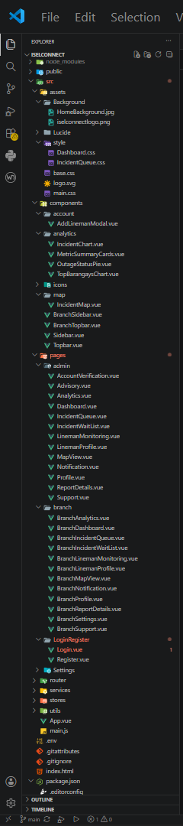 | □ Configuration Files Created  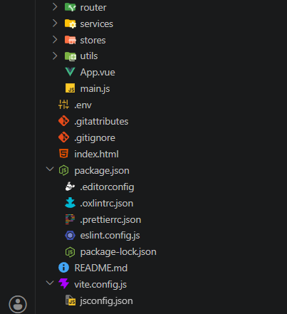
 | □ Framework Running Successfully
ACTIVITY 4
FOUNDATIONAL MODULE DEVELOPMENT

Purpose
To create the basic modules that will serve as the foundation of the system.
Suggested Foundational Modules
- User Authentication
- Login Page
- User Registration
- Dashboard Layout
- Navigation Menu
- Database Connection Module
Procedure
- Develop at least one foundational module.
- Verify module functionality.
- Upload code to repository.
- Complete Form 4.

FORM 4
INITIAL MODULE DEVELOPMENT REPORT

Directions
Document all foundational modules completed.
Module | Description | Status
User Authentication | User registration and login with SMS OTP verification and role-based access (Admin, Lineman, Resident). | Complete
Report Management | Allows residents to submit outage and maintenance reports with live photo capture and location details. | Complete
Admin Dashboard | Enables administrators to view, validate, assign, and monitor reports through an interactive dashboard. | In Progress
Lineman Module | Allows linemen to receive assigned reports, update repair status, and mark completed tasks. | In Progress
Notification System | Sends SMS and in-app notifications to be affected barangays and updates users on report status. | In Progress

Module Testing
Test Performed | Result
Login Function Test | Pass
Database Connection Test | Pass
Navigation Test | Pass

Required Evidence
Mobile
□ Screenshots of Running Module
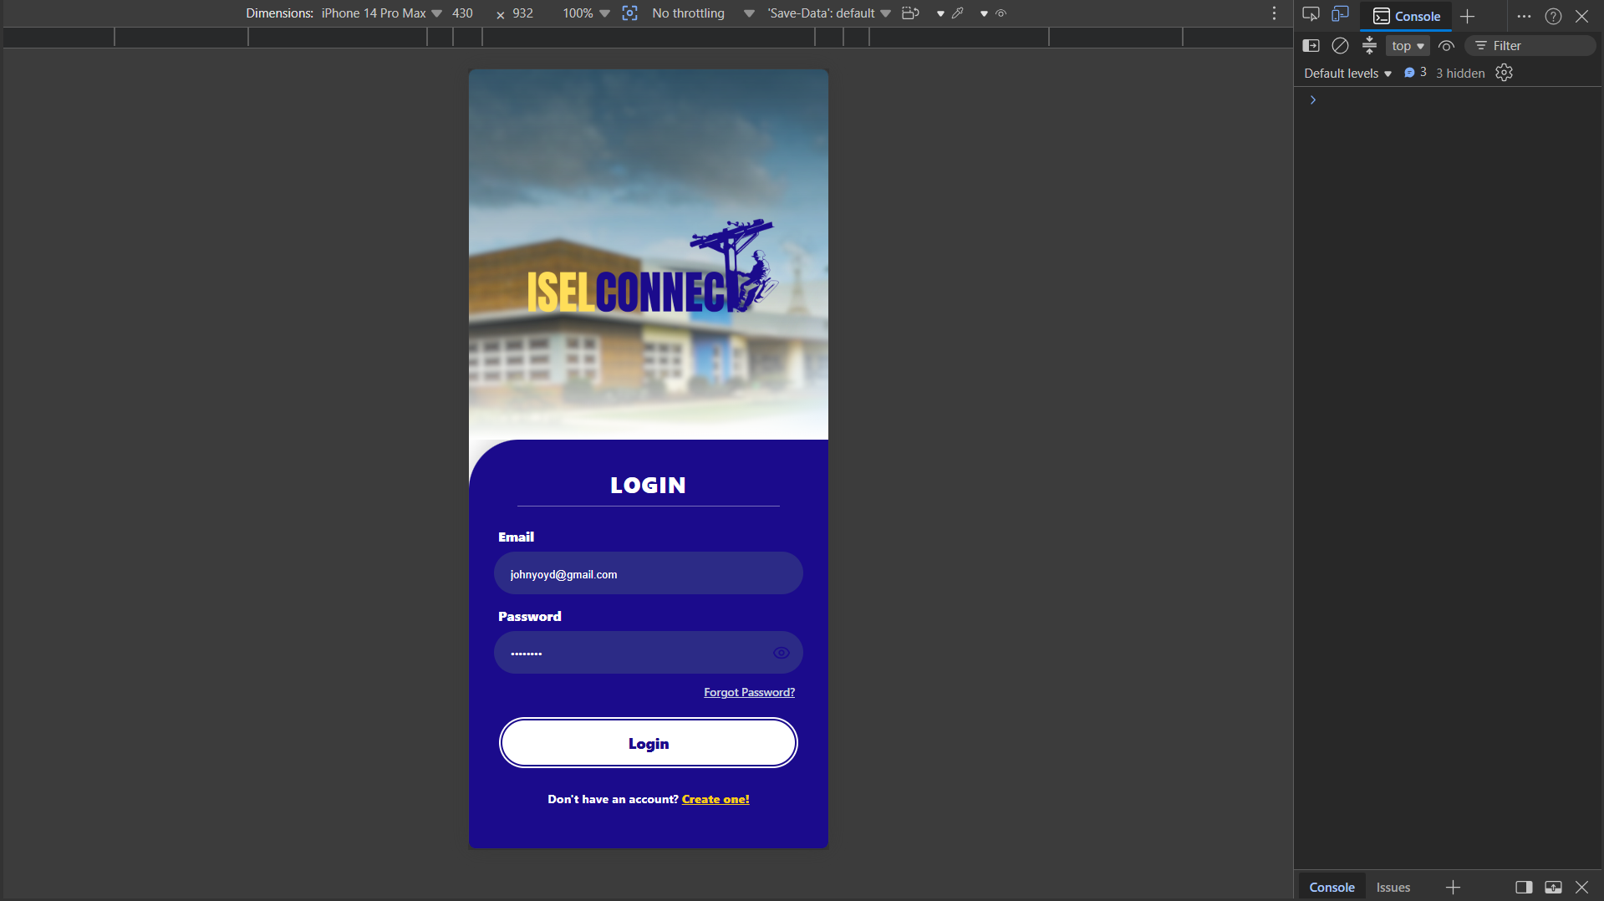

□ Source Code Screenshot
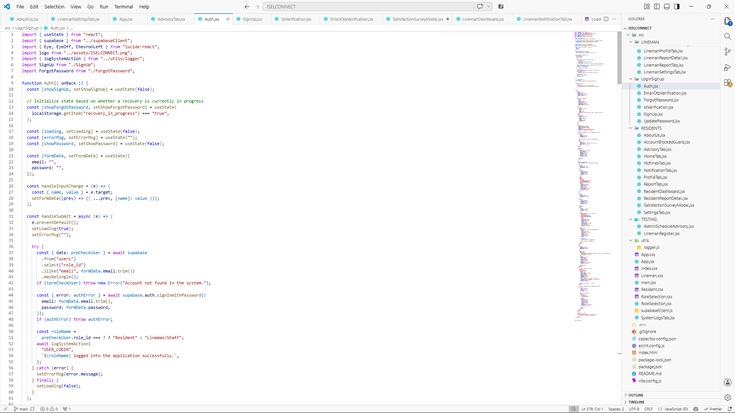
□ Demonstration Screenshot
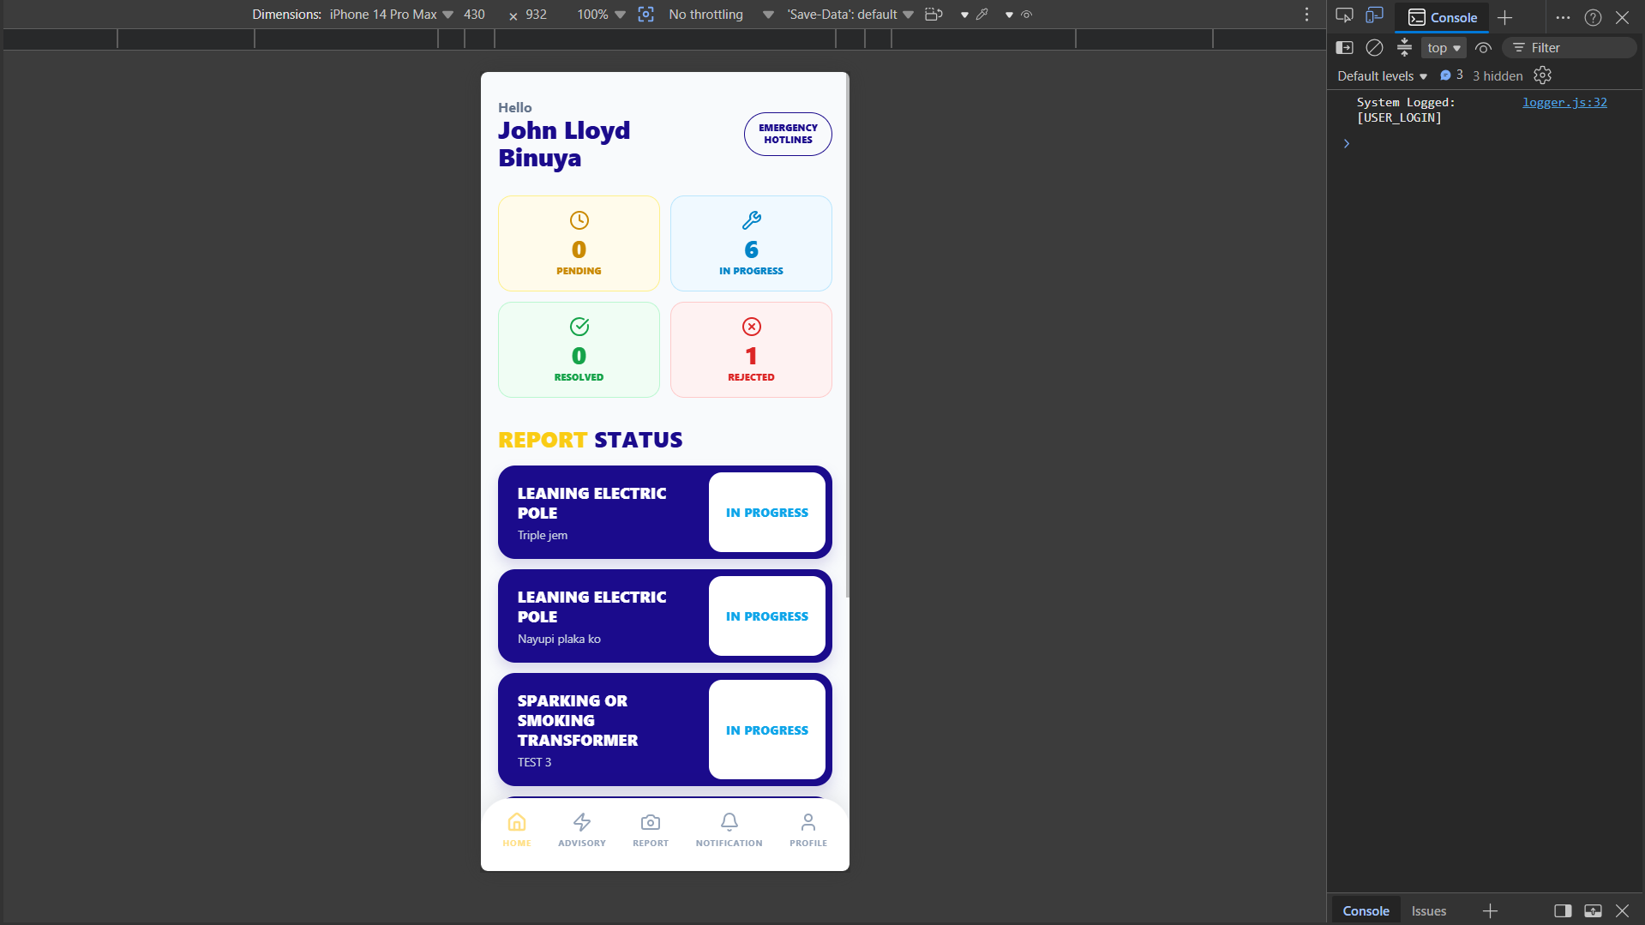

Web
□ Screenshots of Running Module

□ Source Code Screenshot
□ Demonstration Screenshot
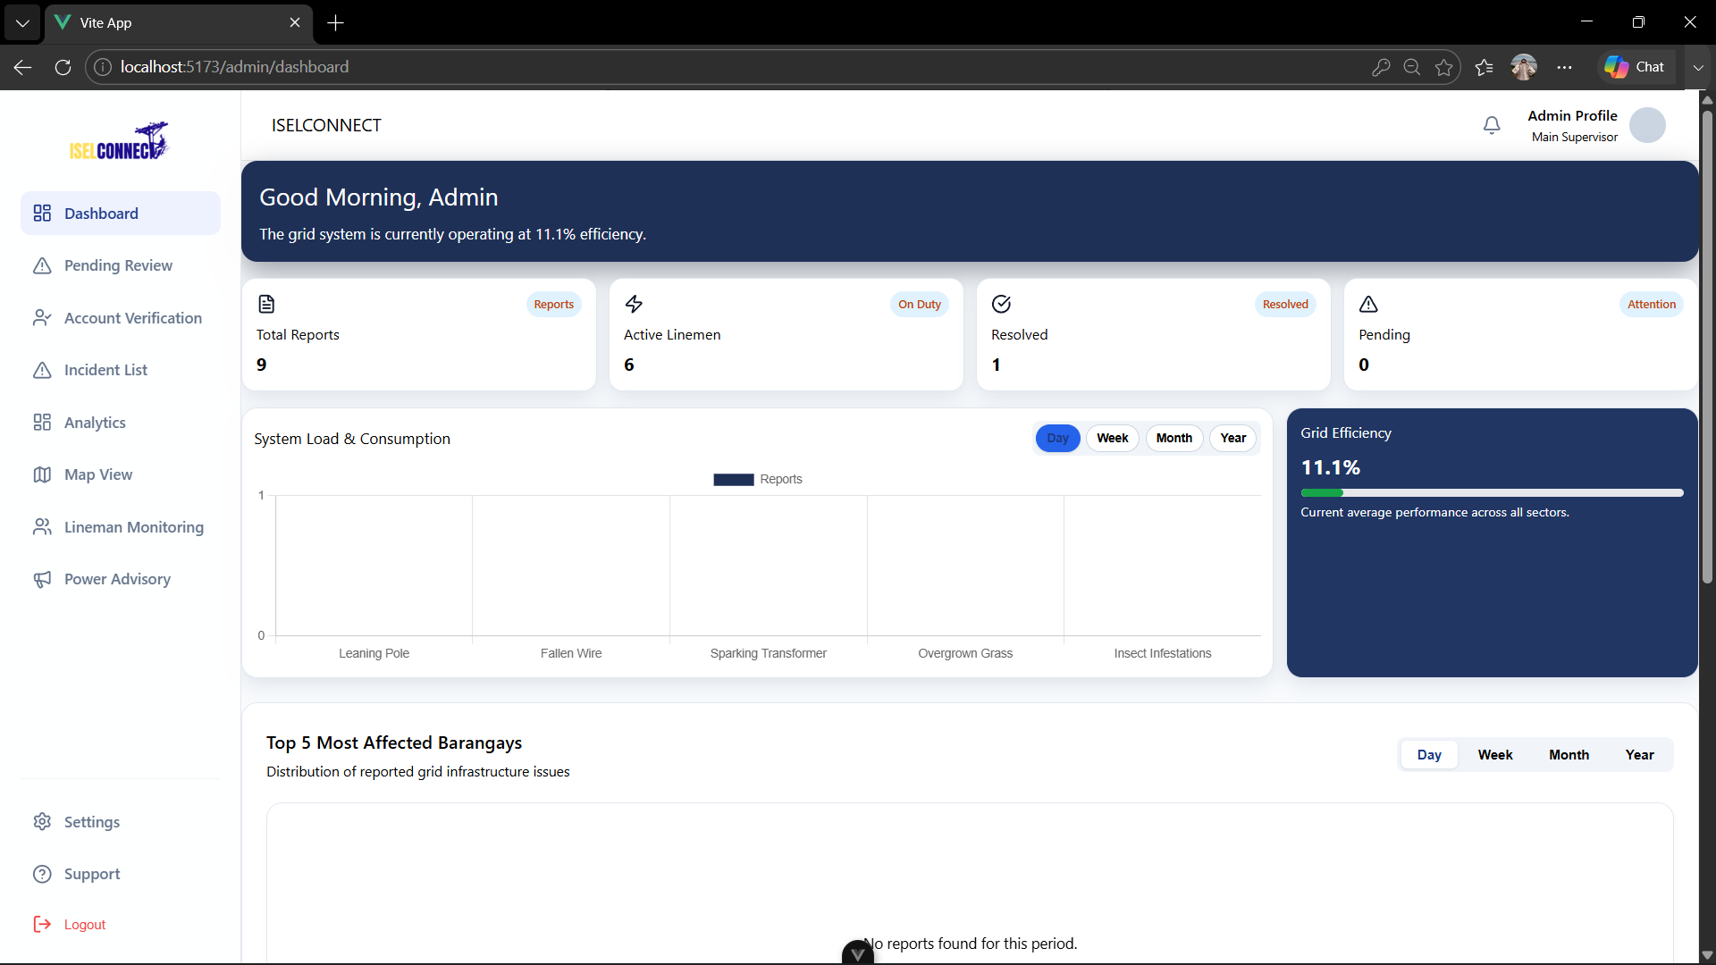

ACTIVITY 5
CODING STANDARDS ESTABLISHMENT

Purpose
To ensure consistency and maintainability of source code.

Procedure
- Agree on naming conventions.
- Define file organization standards.
- Define documentation standards.
- Define commit message standards.
- Complete Form 5.

FORM 5
CODING STANDARDS AGREEMENT

Naming Conventions

Item | Standard
Variables | Use camelCase (e.g., reportStatus, userLocation)
Functions | Use camelCase with descriptive verb names (e.g., submitReport(), validateUser())
Classes
  Use PascalCase (e.g., ReportController, NotificationService)
Tables | Use snake_case and plural nouns (e.g., users, maintenance_reports, notifications)
Files | Use PascalCase for component files (e.g., AdminDashboard.vue, ReportForm.jsx) and kebab-case for other files when applicable (e.g., auth-service.js, api-client.js)

Documentation Standards
□ Source Code Comments Required
□ Function Documentation Required
□ Database Documentation Required

Repository Standards
Commit Format: When committing, we make sure to input on the description what we fix and what we accomplish.

Branching Strategy: None

Team Agreement
All members agree to follow the coding standards established above.
Member Signatures:

ACTIVITY 6
REPOSITORY INITIALIZATION

Purpose
To establish version control and collaboration mechanisms.
Procedure
- Create project repository.
- Upload project structure.
- Commit initial files.
- Add team members.
- Complete Form 6.

FORM 6
INITIAL SOURCE CODE REPOSITORY REPORT

Repository Name: ISELCONNECT

Repository URL: https://github.com/ISELCONNECT-ORG

Team Access
Member | Access Granted
Mark Justin F. Balisacan | Yes
John Lloyd A. Binuya | Yes
Allysa Reyes | Yes

Initial Commits
Mobile
Commit Description | Date
First Clean Commit | June 27, 2026
Power Advisory and Notification testing | June 27, 2026
Branchs | June 30, 2026
Switch to leaflet map | July 2, 2026
Nearly fix transitions | July 2, 2026
Fixed settings transition | July 9, 2026
Survey, Report Remarks, Privacy Act, Landing Screen, Report Auto Fill up, and Advisory time fixed | July 15, 2026
Valid ID Verification, Email OTP, Lineman Location Tracking, Resident Account Verification, and Report Verification | July 18, 2026
Report Priority Level Arrangement | July 18, 2026
Area Alert, CSS, and L-reportlogs | July 20, 2026
Forget password | July 20, 2026
Functional on mobile | July 22, 2026
Mirrored Camera and Map Direction Line Fixed | July 23, 2026
Account Banning and report Rejecting | July 28, 2026

Web
Commit Description | Date
Initial Commit | June 29, 2026
Initial | July 2, 2026
Initial Commit | July 9, 2026
UpdateLogin | July 23, 2026
IncidentReport | July 23, 2026
RejectReport | July 28, 2026
AccountVerification | July 28, 2026

Required Evidence
Mobile
□ Repository Homepage Screenshot

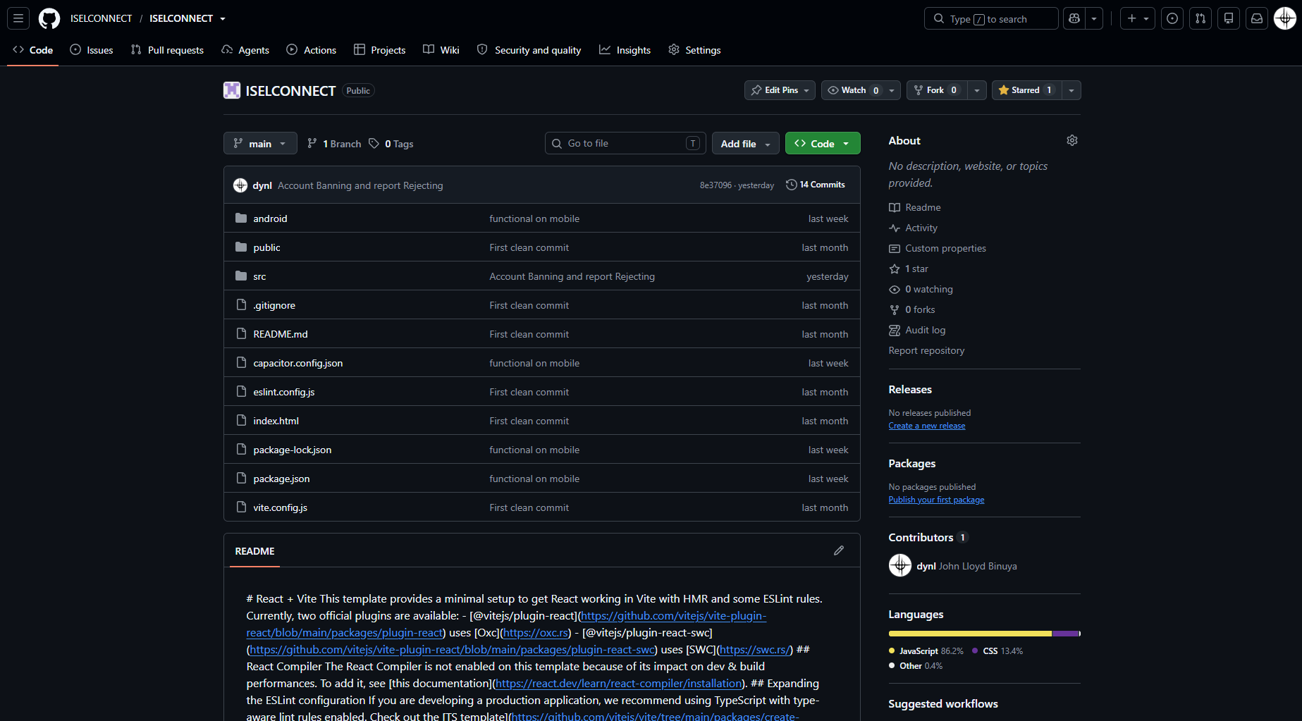

□ Initial Commit Screenshot
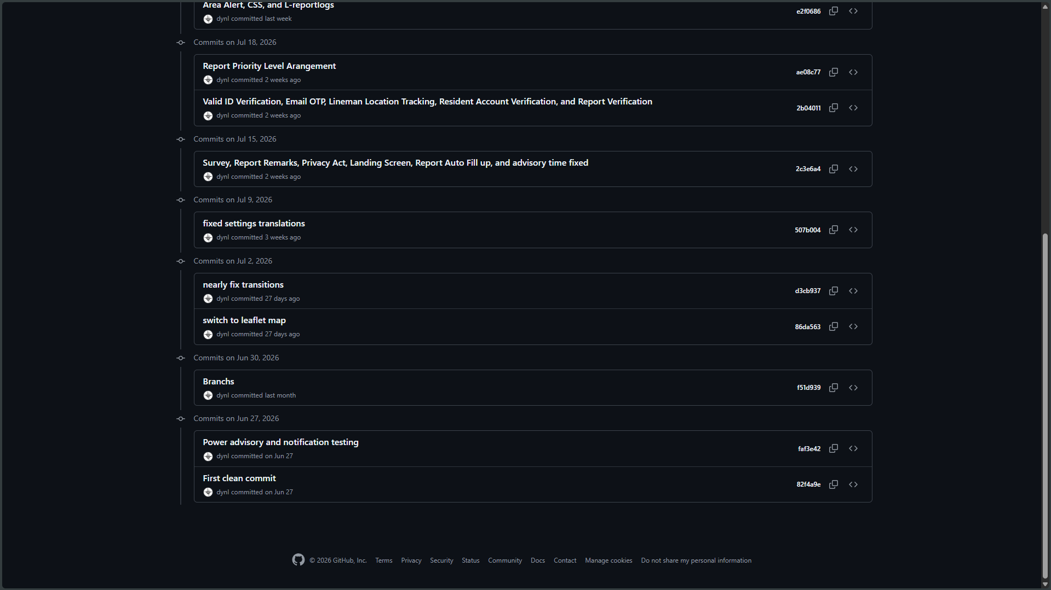
□ Project Structure Screenshot
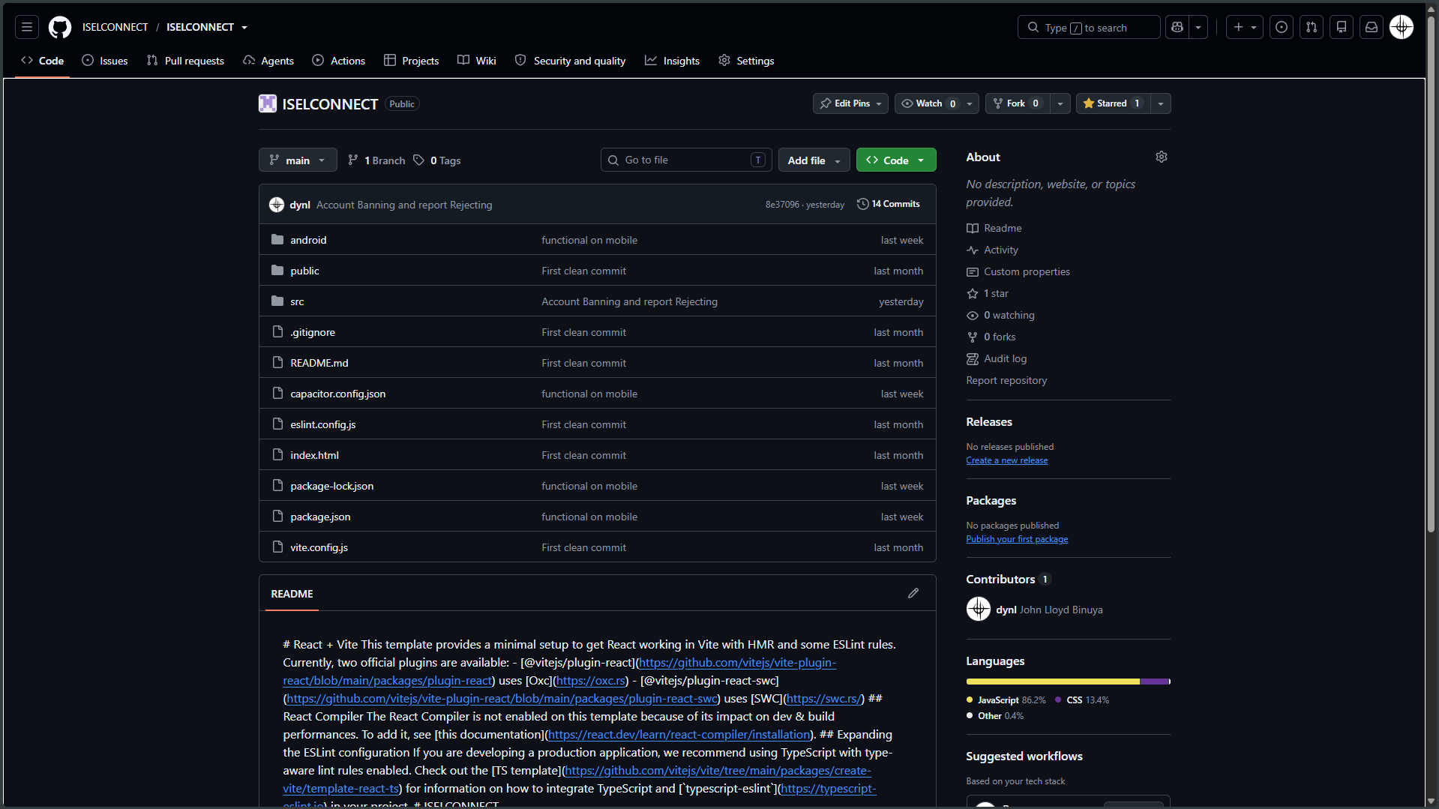
□ Team Access Screenshot
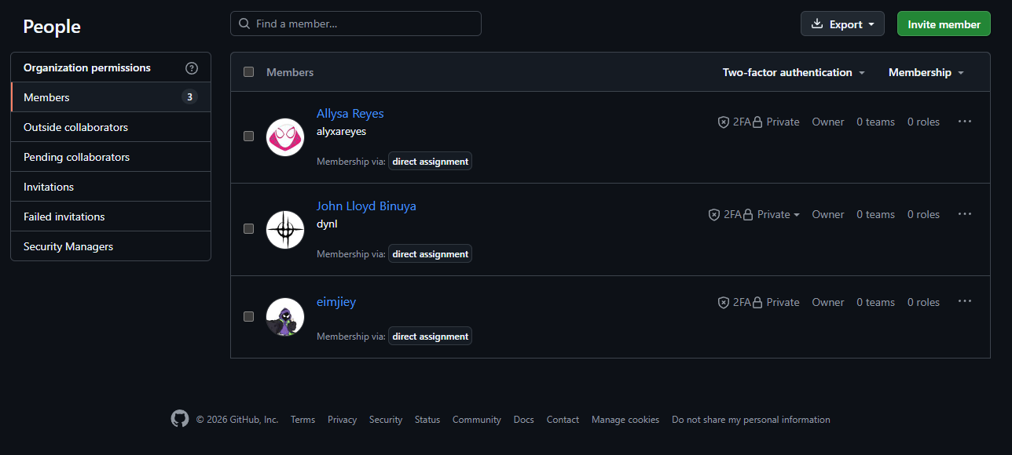

Web
□ Repository Homepage Screenshot
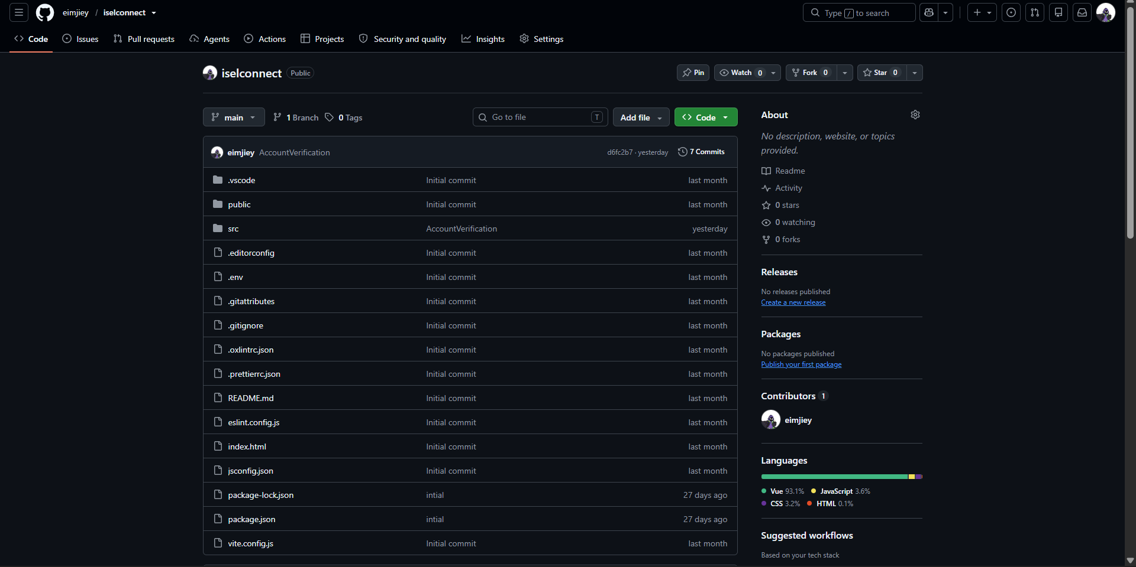

□ Initial Commit Screenshot
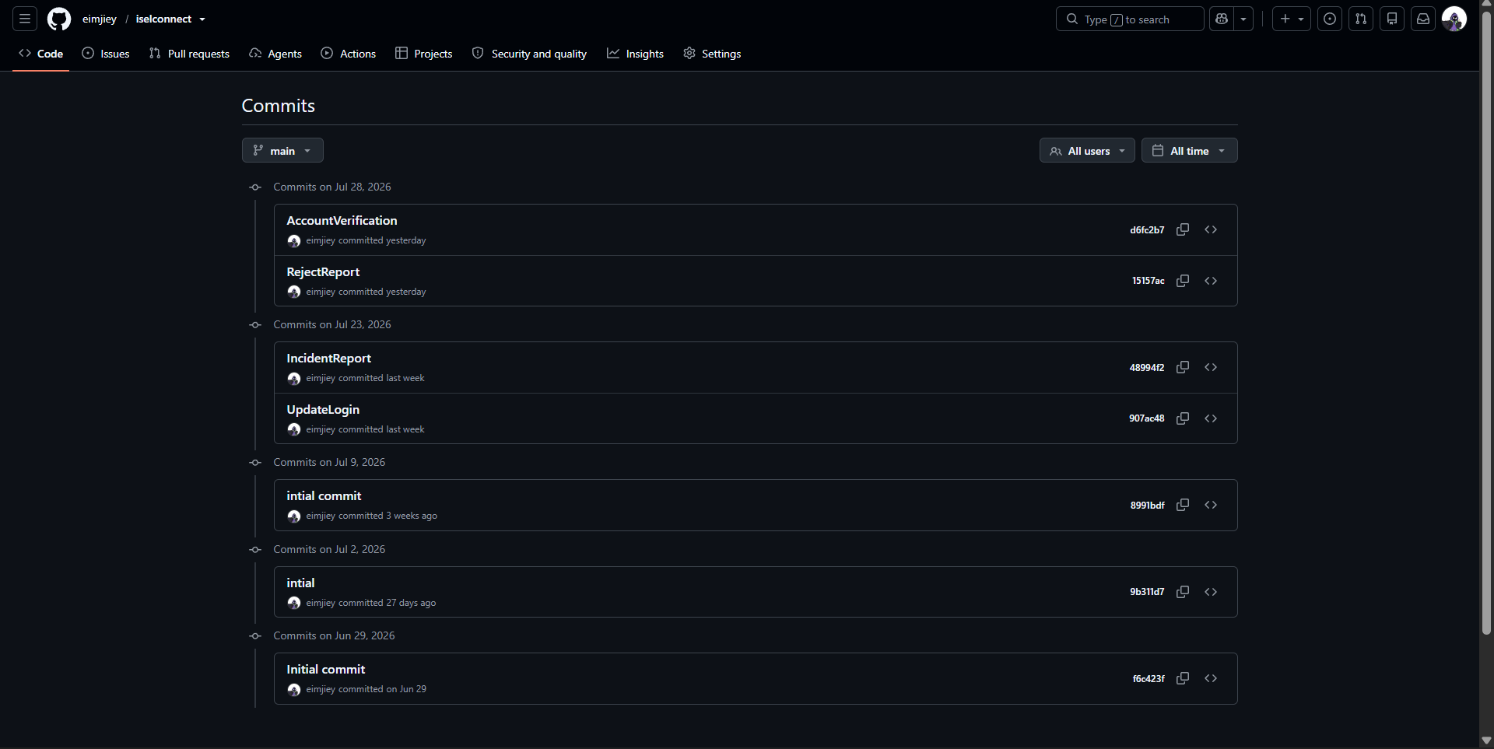
□ Project Structure Screenshot
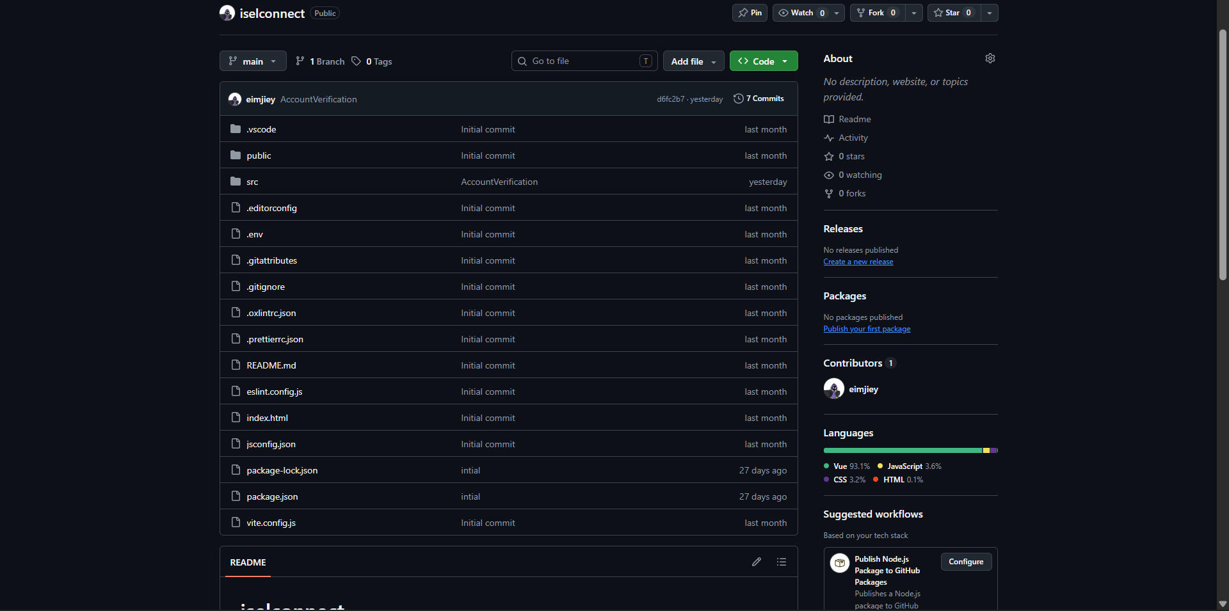
□ Team Access Screenshot

ACTIVITY 7
ADVISER VALIDATION
Purpose
To verify readiness for full-scale system development.
Procedure
- Present all Week 2 outputs.
- Demonstrate development environment.
- Demonstrate database implementation.
- Demonstrate initial modules.
- Obtain adviser approval.

FORM 7
ADVISER VALIDATION RECORD

Item Evaluated | Status
Development Environment | Approved
Database Implementation | Approved
Initial Modules | Approved
Coding Standards | Approved
Repository Setup | Approved

